Word Rhyme Assessment
Name: __________________________________ Date:________________

Rhyme of the Week: _______________________ Rubric Level:__________

Teacher should complete all responses below based on student interaction.

- Show the vocabulary cards of the rhyme and ask, “Can you say these words in English?”

Response:

- How do these words end? (gives rhyme) _______________________________

- Give me a word that rhymes with __________.

Response:

Circle One:
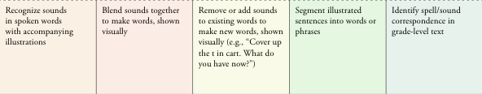

Teacher Observations/ Next Steps:

